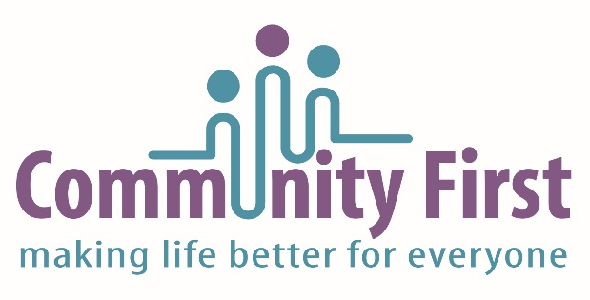

Wheels to Work Scheme Application Form

1. Name of applicant
Address

Post code

Date of Birth _ _ / _ _ / _ _ _ _ Age _____ Male Female

Home telephone number

Mobile number

E-Mail

2. Referring Agency/Employer

Name of referring person

Address

Post code

Contact telephone number

Email address

Self referral - Yes No

Where did you hear about the scheme?

3. Name of Guarantor

Address

Post code

Relationship to applicant

Contact telephone number

Email address

I have read and accept the terms and conditions of the Guarantor agreement

Signature of Guarantor Date

4. Date from which moped is required

5. Applicant’s situation

Please indicate, by ticking the boxes below any of the following criteria that applies

Lives in rural area No private transport**
No suitable public transport* Need to find employment/attend interviews

To access work based training To access employment

*Please give details as to why the public transport is not suitable.

**Is it possible for the hirer to obtain a lift from a friend / colleague?

6. Place of employment/work based training/job centre

Name of employer/work based training

Address

Phone no

7. Distance of journey from home to employment/training in miles/km

8. How will the moped loan make a positive difference to your life?

9. Long term transport plans

The loan period is 3 or 6 months depending on circumstances. This may be extended to a maximum of one year at our discretion. During the loan period, users should be preparing alternative transport plans for when the scheme comes to an end. Please outline below your plans for future travel to work.

- Driving licence and Compulsory Basic Training (CBT).

Do you hold a full/provisional licence with motorcycle entitlement? Yes No
NB. You are responsible for providing your own licence which must be your current address, and we are unable to proceed with your application without one.

If yes, please give licence number

Have you ever ridden a moped/motorcycle ? Yes No

Do you hold a valid CBT Certificate Yes No Date of CBT certificate _ _ / _ _ / _ _ _ _

CBT certificate number

- National Insurance Number

By providing CF with your driving licence and NI numbers you are giving us permission to check your driving licence status via the necessary agency for our insurance/hirer terms.

- Eye sight
Can you read a number plate from a distance of 20 meters? Yes No

If you wear glasses or contact lenses to meet the above requirement, you must wear them every time you drive/ride. Your eye sight will be checked before the CBT takes place and if it is not satisfactory you will not be able to continue with the training.

The information given will be added to a computer system for the purposes of maintaining our Wheels to Work administration. Please tick the boxes below to give your consent on how we will communicate with you and use your personal information.

I give consent to my information being kept on Community First’s (CF) system for administrative purposes.

I give consent to receiving emails, mail, social media posts containing information on Wheels to Work and updates.

I give consent for CF to share my personal data with external organisations, should it be necessary for the purposes of delivering this service to me.

Please return the completed form to:

Wheels to Work Moped Loan Scheme
Community First
First Floor Offices, 71 Christchurch Road, Ringwood BH24 1DH

Tel: 01425 482773

Email:
mopedadmin@cfirstorg.uk for New Forest & Test Valley
mopedloan@cfirst.org.uk for Winchester & East Hampshire

Hampshire Wheels To Work Moped Loan Scheme
Insurance Form
In the event that the application is successful, Community First will make an application for fully comprehensive insurance on your behalf. The insurance premium will be paid for by the Moped Scheme, and any claims should be made via the Community First New Forest.

Please note that you may be asked to make a contribution towards repair costs in the event of damage to the moped caused by negligence.

These questions will enable our insurance company to assess your eligibility for insurance - please indicate by ticking boxes below Yes No
Have you ever been involved in a motor accident or made a claim
against a motor insurer in the last five years?
Have you been convicted of any motoring offences or had
a licence suspended in the past five years, or have any
prosecutions pending?
Have you ever been convicted of any criminal offences?
Have you ever suffered from any physical or mental infirmity,
diabetes, heart condition or fits?
Have you ever been refused, quoted an increased premium or had
special terms imposed by an insurance company?
Have you been resident in the United Kingdom for less than three years?

If the answer to any of the above is ‘yes’, it may not exclude you from the scheme, but you must give full details on a separate securely attached sheet.

Your application will be subject to approval by the Insurance Company.
IF ANY OF THE ABOVE CHANGES BEFORE OR DURING THE HIRE PERIOD, IT IS YOUR RESPONSIBILITY TO INFORM COMMUNITY FIRST IMMEDIATELY.

I declare that to the best of my belief all the statements made above are true and complete and all other information I have given relating to my application for a moped loan is true, correct and complete and that I have not withheld any material fact which might influence an insurer in the acceptance of the risk. I understand that any misrepresentation or change in circumstances could result in the withdrawal of the moped loan.

Signed (applicant) Name (Print)

Date

Return the completed form to Wheels to Work Moped Loan Scheme, Community First, First Floor Offices, 71 Christchurch Road, Ringwood BH24 1DH

I confirm that this form was completed with my assistance and that the applicant fully understood the form.

Signed (referring agent) Name (Print)

Date

